Erewash Class Homework
Date : Friday 25th September Due : Friday 2nd October
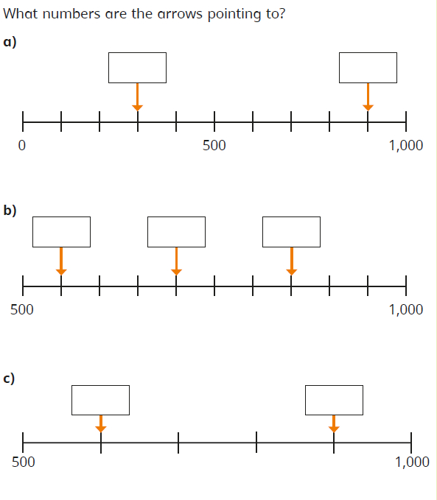
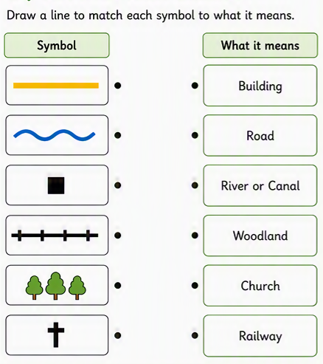
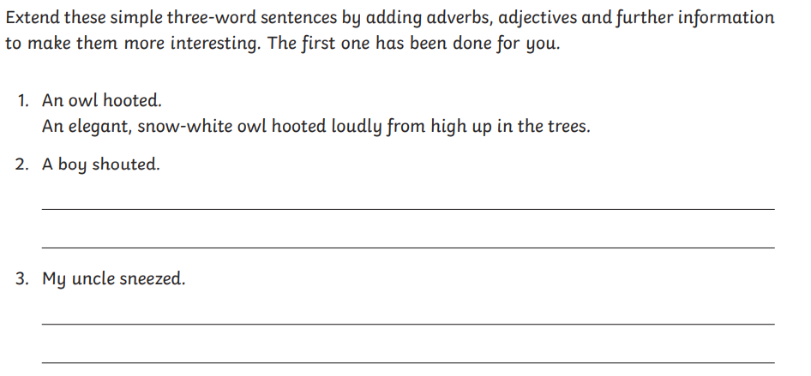
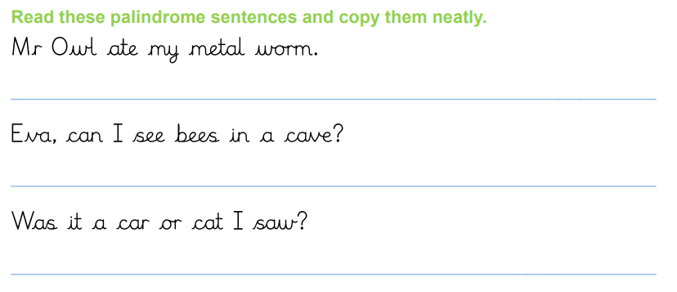
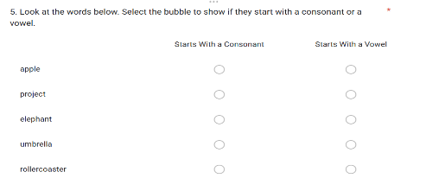
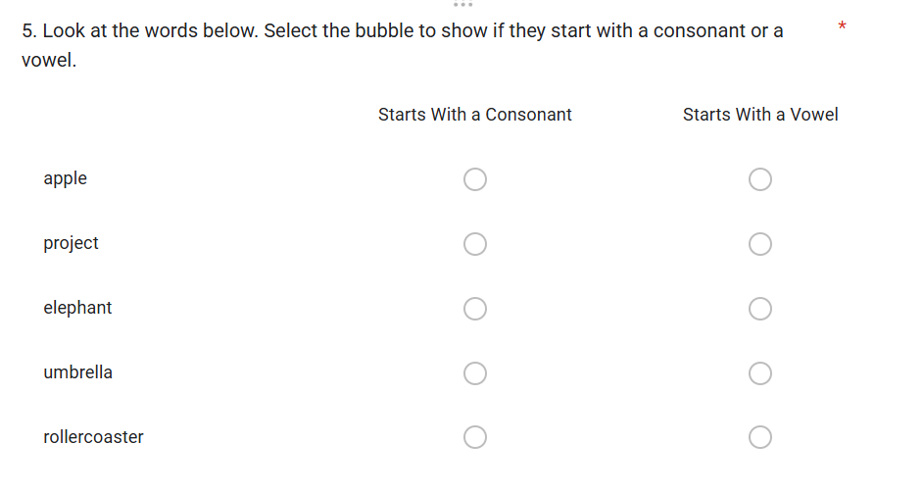
Can you retell the story of Noah’s Ark? You can do this any way you would like.
Extend these sentences by adding adverbs, adjectives and further information to make them more interesting. The first one has been done for you.

